Awaiting resolution of image copyright
File not yet proofed
65.10.11b
Transfer of Title
archival location?, SA.

[South Australia.
(A)
APPLICATION TO BRING LANDS UNDER THE PROVISIONS OF THE REAL PROPERTY ACT OF 1861.
I, Ferdinand Mueller of Melbourne in the Colony of Victoria, Gentleman do declare that I am seised of an estate of freehold in fee simple in all that piece or parcel of land situated in the Hundred of Blanche County of Grey being the Eastern Moiety of the Section of land numbered 368 in the plan of the said Hundred and containing 40 acres or thereabouts: Which said Section of land is described more fully in the Land Grant thereof registered No. 367 Book 83, and the Eastern Moiety hereby conveyed is delineated in the subjoined plan and therein colored green

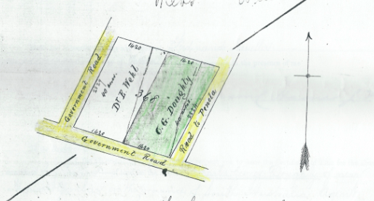

which piece of land is of the value of Four hundred pounds Sterling and no more, and is the Easterly half of that Section of land originally granted to me by land grant, under the hand and seal of Sir Henry Edward Fox Young Lieutenant Governor of the Province of South Australia, dated the Seventeenth day of June 1854, numbered 368 in the plan of the said Hundred of Blanche County of Grey as delineated on the public maps of the Province deposited in the Survey Office in Adelaide: And I do further declare that I am not aware of any mortgage, encumbrance, or claim affecting the said lands, or that any person hath any claim, estate, or interest in the said lands at law or in equity, in possession or in expectancy, other than is set forth and stated as follows, that is to say—
And I further declare there is no person in possession or occupation of the said lands adversely to my estate or interest therein, and that the said land is now occupied by Charles George Doughty and that the adjoining owner is Dr Wehl and that there are no deeds or instruments of title affecting such land in my possession or under my control, other than those enumerated in the Schedule hereto: And I made this solemn declaration, conscientiously believing the same to be true, and do hereby apply to have the piece of land described in the above declaration brought under the provisions of the Real Property Act of 1861.
Dated at Melbourne Victoria this eleventh day of October 1865
Ferd Mueller, M.D.

Made and subscribed by the above-named Ferdinand Mueller this eleventh day of October 1865 in the presence of me
William C Haines J. P.

To the Registrar-General—
I, the above declarant, hereby request you to issue the Certificate of Title for the above mentioned half Section of land, in the name of Charles George Doughty of near Mount Gambier in the province of South Australia, Agent.
Ferd. Mueller, M.D.

Witness to signature–
William C Haines J. P.

This application is correct for the purposes of the Real Property Act.
Nathl. Oldham
L. L. Br.

SCHEDULE REFERRED TO.
Land Grant dated 17th June 1854 Registered No. 367 Book 83 signed by H. E. F. Young granting unto Ferdinand Mueller Section No. 368 near Mount Gambier County Grey containing 80 acres or thereabouts. Considn. £151 - -

65-10-11b_image01.jpg
The space that follows on the printed document has been left blank.
Doughty and his wife, M's sister Bertha, had until her death on 7 September 1861 been living on a pastoral property at St Helens, Vic, some distance from the nearest town of Port Fairy. It would seem that following Bertha's death, Doughty had moved with their two small children to a less isolated property near Mount Gambier, SA, owned by M and next door to M's other sister Clara Wehl and her family, and that M was now transferring ownership of the property to him.
Marginal annotation: ‘Certificate issued Vol: LXXV Folio 130’.
Licensed Land Broker.
Annotated: 'The Land Grant to be returned when Eastern Moiety is cancelled | N.O.' and 'Received the abovementioned Land Grant. | Clemt. H. Oldham | pro N. Oldham | 1st December 1865'.

